1. **1-**Create position (which will be Advertised)                             **PPOME**

Create Position which is going to be Filled.

[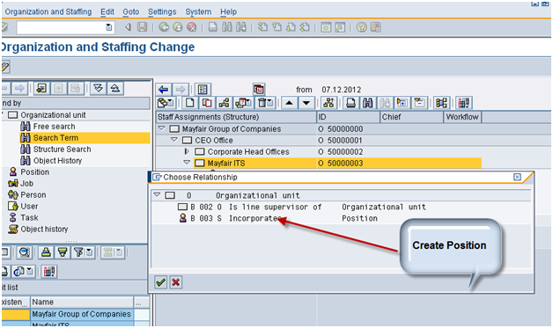](https://blogs.sap.com/wp-content/uploads/2013/01/pastedimage_2_171222.png)

***Step 2:***

1. **1-**Maintain Position Requirement                                                    **PPPM**

Maintain requirement for the position

                 E.g MBA +2 Years Experience.

                [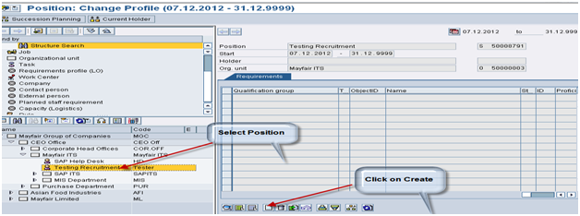](https://blogs.sap.com/wp-content/uploads/2013/01/pastedimage_4_171278.png)

***Step 3:***

1. **1-**Advertisement   Jobs **PBAW**

Advertise the jobs on the medium

Which has already been created through

[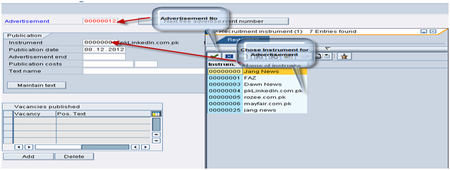](https://blogs.sap.com/wp-content/uploads/2013/01/pastedimage_7_171280.png)

***Step 4:***

1. **1-**Run Applicant action                                                                          **PB40**

Run T-code PB40 and chose Initial Entry Of basic Data Action

                This action has Following Info types which are Already Configured.

Info type: 0001,0002,0006,4001

                     & 0022(Education), 0023(Employer), Qualification (0024).

                    [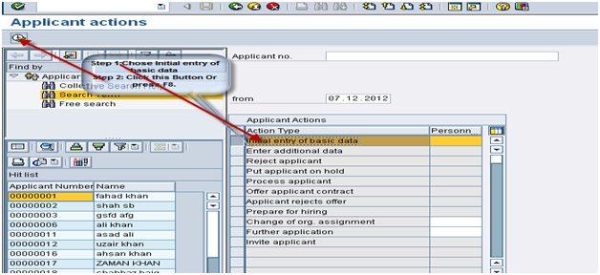](https://blogs.sap.com/wp-content/uploads/2013/01/pastedimage_11_171283.png)

***Step 5:***

1. **1-**Profile Matchup **PEPM**

Matchup Job Requitement with the Applicant Qualification.

[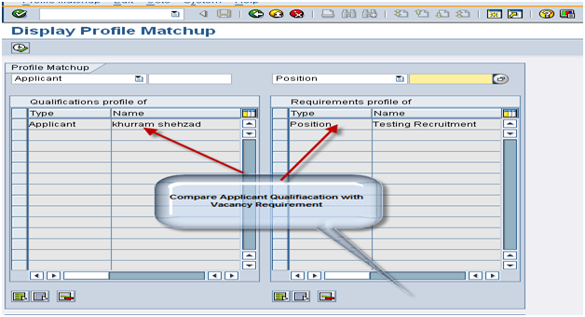](https://blogs.sap.com/wp-content/uploads/2013/01/pastedimage_14_171284.png)

***Step 6:***

1. **1-**Interview Invitation                                                                           **PB40**

Chose Action Interview Applicant

After profile matchup of successful

Applicant

Reject Applicant, On Hold Applicant,

[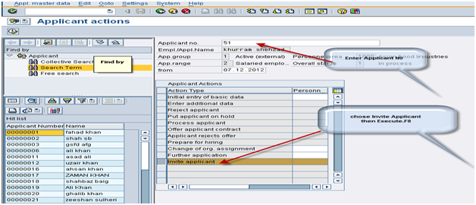](https://blogs.sap.com/wp-content/uploads/2013/01/pastedimage_17_171285.png)

***Step 7:***

1. **1-**Prepare For Hiring **PB40**

After Interview if Applicant Selected will be

Given Offer  letter.

After accepting offer applicant action

Prepare for hiring will be run

***Step 8:***

1. **2-**Transfer Data from Recruitment  to PA                                    **PBA7**

In last Applicant Data will be transfer into

SAP system Through T-Code PBA7

[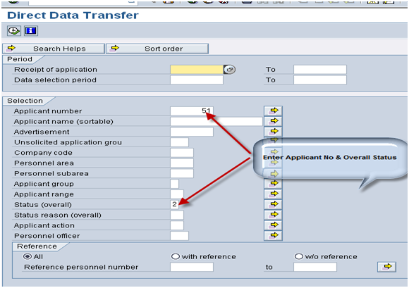](https://blogs.sap.com/wp-content/uploads/2013/01/pastedimage_20_171286.png)